Problem 1)

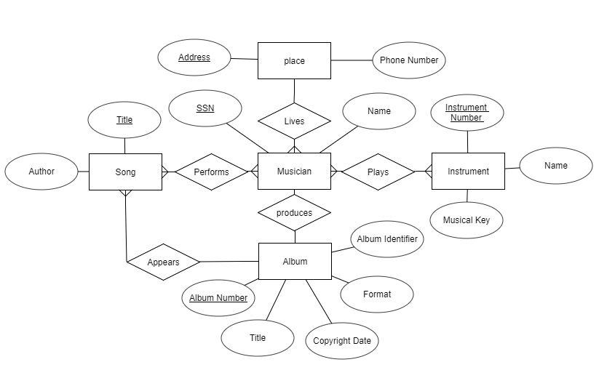

Problem 2 Assumptions)

1. Student table - Student id - unique

course table - course id - unique

section table - CRN - unique

b) Instructor - Employee id - unique

c) building - building id - unique

building - room id - unique

sections take place in one building

sections take place in one room

sections exist in that room for a specific time

My Solution to problem 2)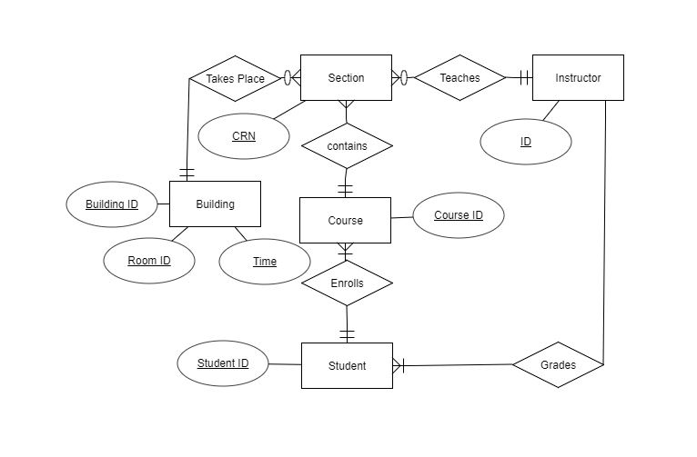

Problem 3)

